DELHI TRAFFIC POLICE DATED 05.09.2014

PRESS RELEASE

Delhi Traffic Police wins awards in the field of Road Safety Campaign and Creative Excellence

Delhi Traffic Police has been actively contributing towards imparting Road Safety education to all categories of road users and drivers such as school children, college students, commercial vehicle drivers, DTC drivers, police and army personnel, drivers of both organized and unorganized sectors and other motorists in which they are given lectures and training on safe driving, lane discipline, effects of drunken driving and other important aspects of road safety. The staff of Road Safety Cell of traffic police visit schools, display mobile exhibition van at important places and distributes pamphlets on Road Safety to various road users of Delhi. Film Shows for imparting road safety education are also organized for general public in various parts of Delhi. To encourage community participation traffic Wardens are appointed. Traffic Wardens serve as a bridge between the traffic police and the community for better understanding of local and general traffic problems. A total of 350 schools and 2 colleges are enrolled as members of the Road Safety Club.

Delhi Traffic Police also has 5 Traffic Training Parks at i) Pragati Maidan ii) Bal Bhawan iii) Roshanara Bagh iv) Baba Kharak Singh Marg and v) Punjabi Bagh. Regular visits of school children and teachers are organized to these Traffic Training Parks to educate them on road rules.

Sustained media campaigns have been undertaken through electronic & print media and outdoor advertising to sensitize general public on road safety issues.

In recognition of the initiative the Delhi Traffic Police has been conferred the “Campaign of The Year Inks Award – 2014” in the field of enhancing Road Safety.

In addition, Delhi Traffic Police has been granted winners certificate for “Creative Excellence” in recognition of outstanding media initiatives entered in “Excellence in Advertising Awards – 2014” including devising a game for children for imbibing road safety ethics and norms.

(Anil Shukla)
Joint Commissioner of Police
Traffic, Delhi.

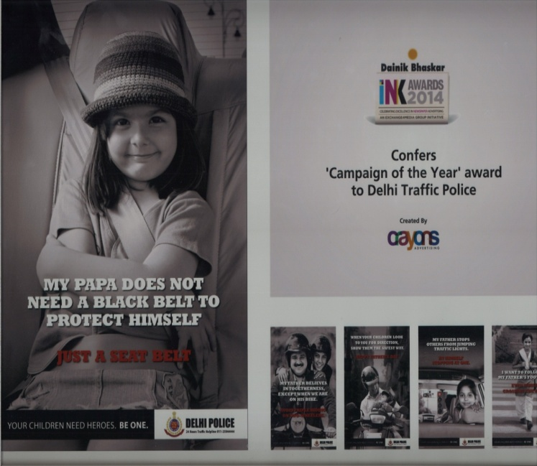 | 